Android Developer Bootcamp
Profile Information Screen
Workshop #03
🎯 Purpose
This workshop helps you practice designing a simple profile information screen using XML layout only.
You will use basic UI components to display user details such as name, gender, age, and an image.
🧩 Problem
Design a simple profile information screen UI in Android using XML.
The screen should contain the following elements:
🖼️ Profile Image
• An ImageView at the top of the screen
• Display any image from the drawable folder
• The image should be centered and clearly visible
🏷️ Name
• A TextView displaying the user's name
• Example text: "Name: John Doe"
👤 Gender
• A TextView displaying the user's gender
• Example text: "Gender: Male"
🎂 Age
• A TextView displaying the user's age
• Example text: "Age: 25"
🔘 Submit Button
• A Button at the bottom of the screen
• Button text should be: "Submit"
How to Solve
Checkout the workshop from Git Repo:
- git clone -b
- Open the root folder inside Android Studio
- Open activity_main.xml
- Add an ImageView
- Add Gender
- Arrange all components vertically
- Run the application
🎯 You Will Achieve
After completing this workshop, you will understand:
• How to use ImageView in Android XML
• How to display text using TextView
• How to use Button in XML layouts
• How to arrange views using LinearLayout
• How to create a simple profile screen without Java/Kotlin code
📸 Screenshots
Before Implementation
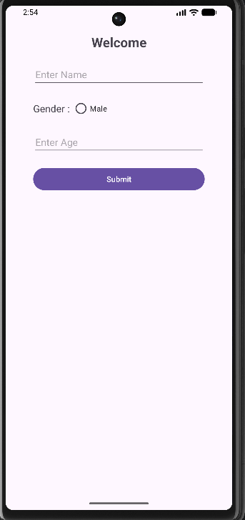
After Implementation

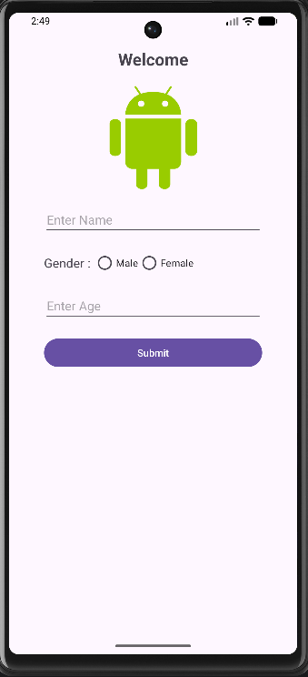

How to submit your workshop
Push your project back to the same git branch using command:
git add .
git commit -m "Completed Profile Information Screen Workshop"
git push origin
🚀 Happy Coding!

